
Cairo University
Faculty of Computers and Artificial Intelligent

CS251
Software Engineering I
Project Name
Software Design
Team Names

Month & Year

Contents
Instructions [To be removed] 3
Team 3
Document Purpose and Audience 3
System Models 3
I. Class diagrams 3
Important Algorithm 4
II. Sequence diagrams 5
Class - Sequence Usage Table 6
Ownership Report 6
Policy Regarding Plagiarism: 7

Team
ID | Name | Email | Mobile
20240519 | Mohamed Alaa Ahmed | 20240519@stud.fci-cu.edu.eg | 01156323478
20240318 | Abd El-Rahman Waheed | 20240318@stud.fci-cu.edu.eg | 01033779086
20231139 | Mohamed Hussein Goma | 20231139@stud.fci-cu.edu.eg | 01128466440
20220023 | Ahmed Tolba Mohamed | 11410120220023@stud.cu.edu.eg | 01112097273

Document Purpose and Audience

Document Purpose and Audience

Purpose of the Document
This document provides the Software Design Specification (SDS) for the Parking Garage System.
It describes the system architecture, class diagrams, activity diagrams, sequence diagrams, and state models required to implement the system.
The goal is to clearly define how the system will operate internally and how its components interact, ensuring that developers fully understand the structure before implementation.

What This Document Is
- A detailed description of the system’s design.
- A reference for developers during implementation.
- A blueprint showing classes, behaviors, interactions, and system logic.
- A technical guide that ensures the system meets its functional and non-functional requirements.

Target Audience
This document is intended for the following readers:
- Software Developers: to implement the system according to the defined design.
- Project Manager: to track design progress and verify design completeness.
- System Analysts: to ensure the design aligns with the requirements specification.
- Quality Assurance (QA) Team: to build test cases based on system flows and interactions.
- Teaching Staff / Course Instructors: to evaluate the correctness and completeness of the design.
- Team Members: to maintain shared understanding of system structure and responsibilities.

System Models

I. Class diagrams
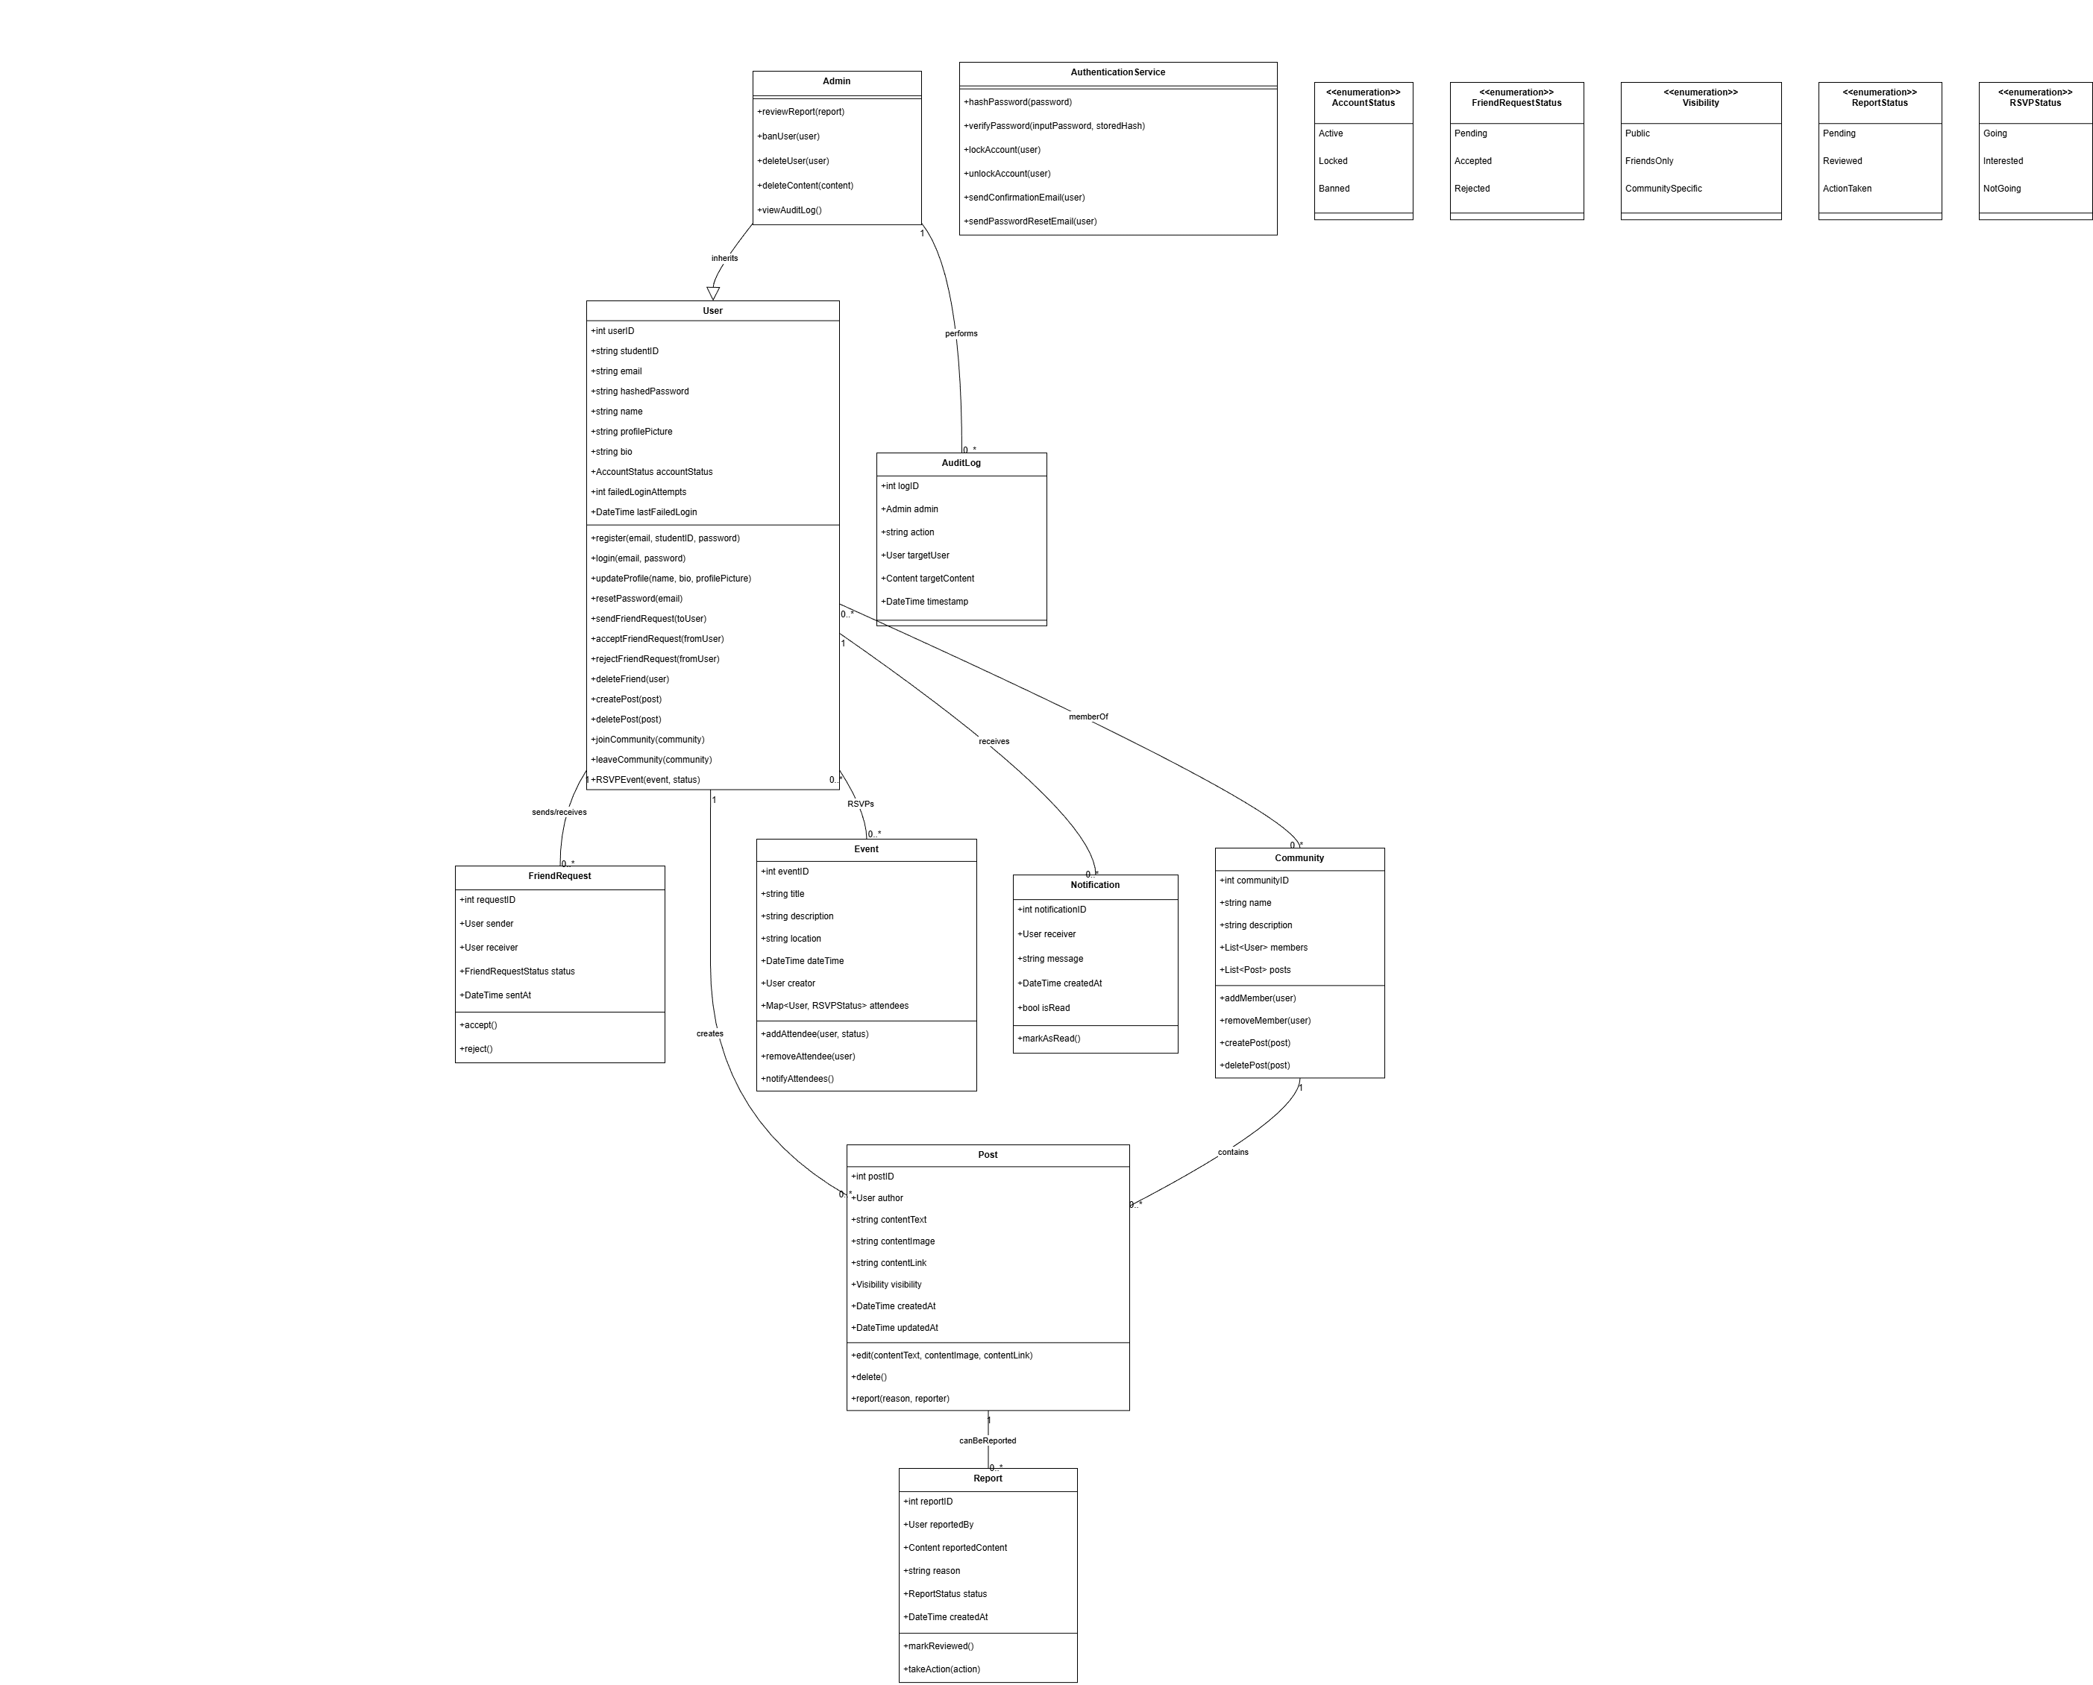

Class ID | Class Name | Description & Responsibility
1 | User | Represents a regular user of the system. Responsible for registration, login, updating the profile, managing friends, creating and deleting posts, joining/leaving communities, and interacting with events (RSVP).
2 | Admin | Represents a system administrator. Inherits from User and adds administrative functions such as reviewing reports, banning users, deleting users or content, and viewing audit logs.
3 | AuthenticationService | Controls authentication and security processes. Responsible for hashing passwords, verifying credentials, locking/unlocking accounts, sending confirmation emails, and handling password reset requests.
4 | FriendRequest | Represents a friend request between two users. Maintains the request status (Pending, Accepted, Rejected) and handles accepting or rejecting the request.
5 | Post | Represents a post created by a user. Contains text, images, or links and manages post visibility (Public, Friends-Only, Community-Specific). Supports editing, deleting, and reporting.
6 | Report | Represents a report submitted for inappropriate content or users. Tracks who reported, the content involved, reason, status, and actions taken by Admin.
7 | Community | Represents an interest-based community. Manages members, community posts, adding/removing members, and posting content within the community.
8 | Event | Represents a campus event. Contains event details (title, description, location, date/time) and manages attendees with RSVP status (Going, Interested, Not Going) and notifications.
9 | Notification | Represents notifications sent to users. Tracks the receiver, message, timestamp, read/unread status, and provides a method to mark as read.
10 | AuditLog | Represents an administrative action log. Records which admin performed which action on which user or content, along with timestamps for auditing purposes.
11 | AccountStatus <<enum>> | Enumeration for User account status: Active, Locked, Banned.
12 | FriendRequestStatus <<enum>> | Enumeration for friend request status: Pending, Accepted, Rejected.
13 | Visibility <<enum>> | Enumeration for post visibility: Public, FriendsOnly, CommunitySpecific.
14 | ReportStatus <<enum>> | Enumeration for report status: Pending, Reviewed, ActionTaken.
15 | RSVPStatus <<enum>> | Enumeration for event RSVP: Going, Interested, NotGoing.

II. Activity diagrams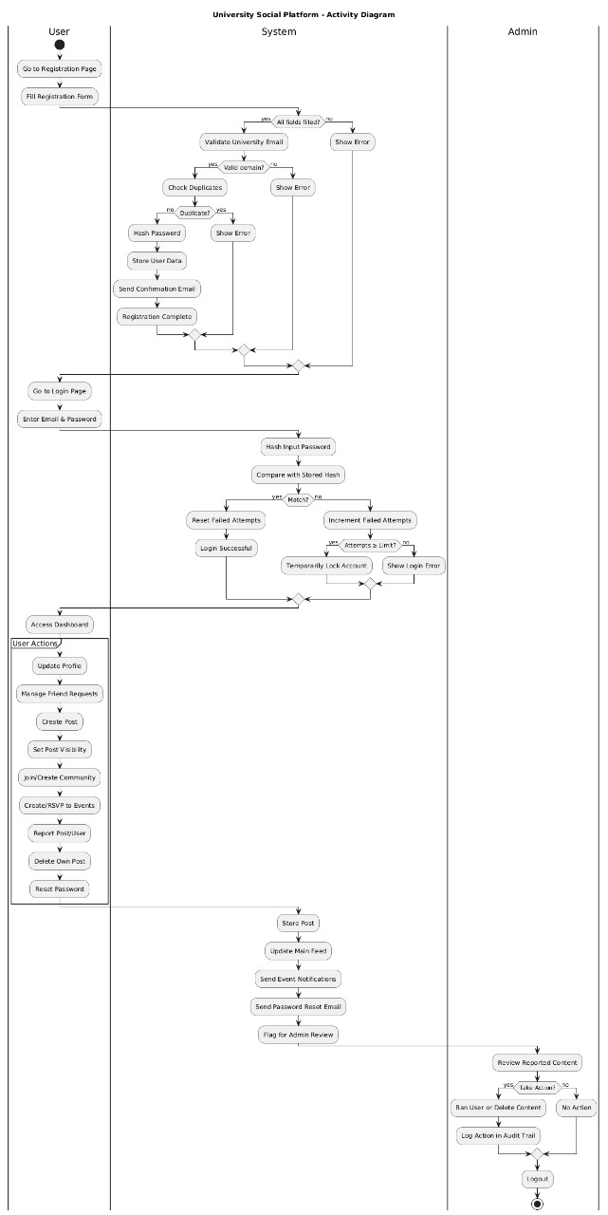

III. Sequence diagrams

Friend Request Management 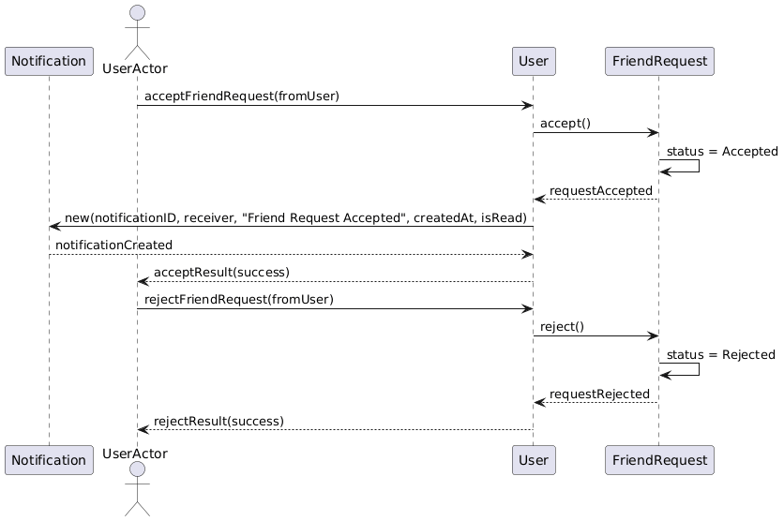

Admin Review System 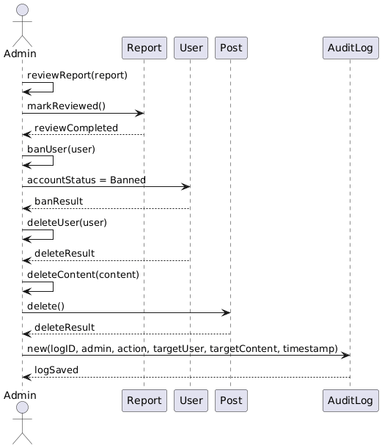
Community Management 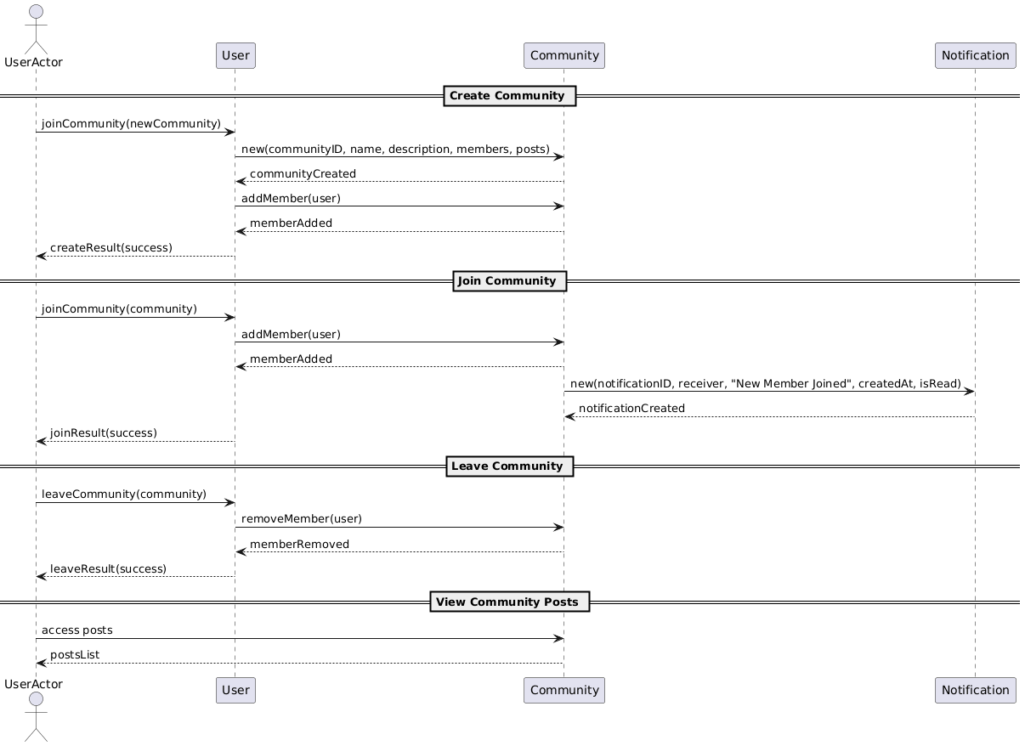

Event Management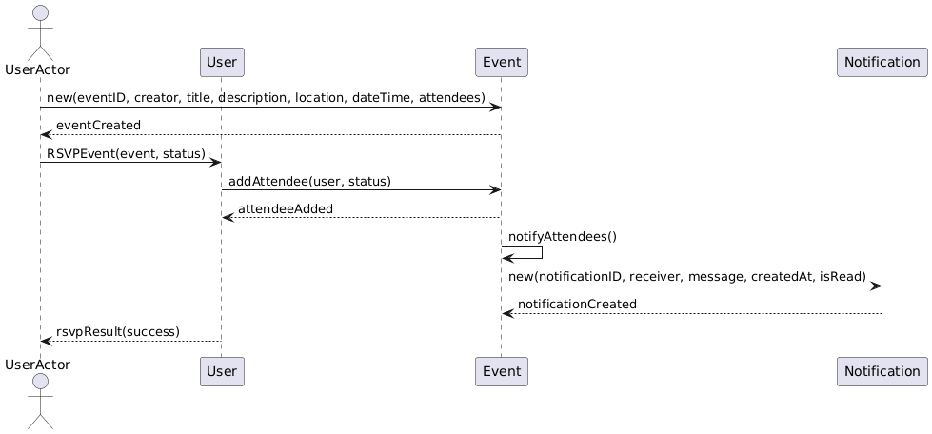
Send Friend Request 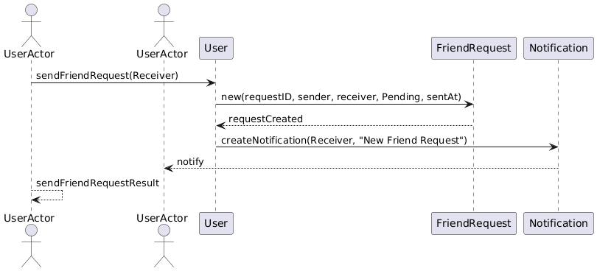
Login Process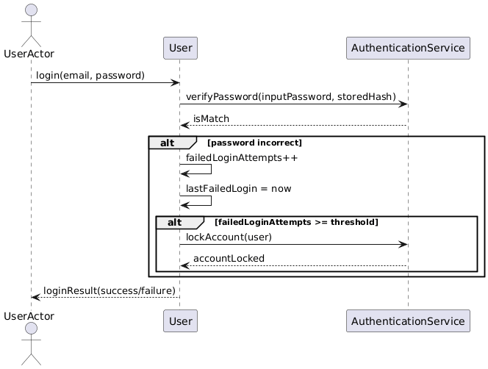
Password Reset
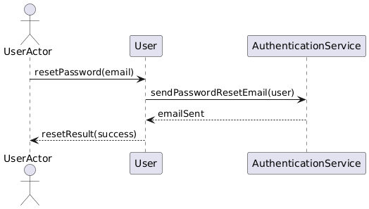
Post Management
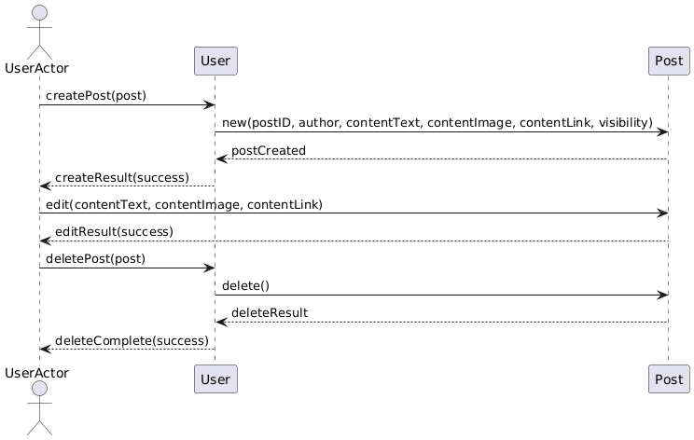
Report Post/User 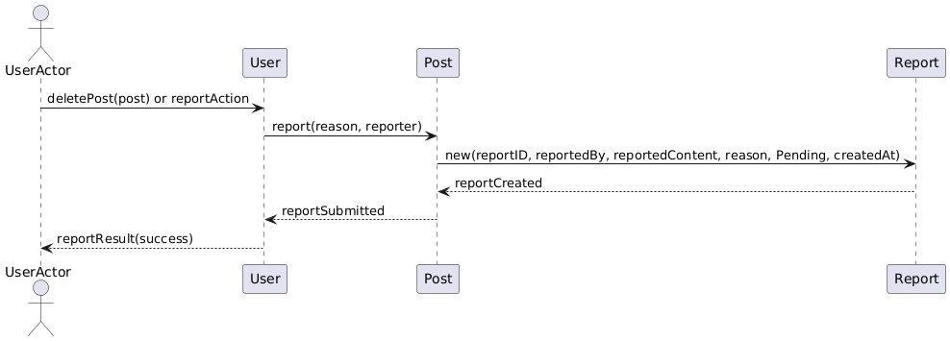 User Registration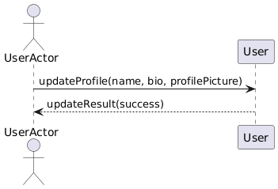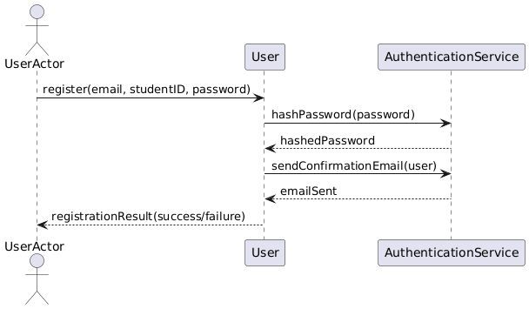

Class - Sequence Usage Table

Class Name | Sequence Diagrams | Overall used methods
User | 1, 2, 3, 4, 5, 6, 7, 8, 9, 10, 11 | acceptFriendRequest(), rejectFriendRequest(), banUser(), deleteUser(), joinCommunity(), addMember(), access posts, addAttendee(), notify(), sendFriendRequest(), verifyPassword(), lockAccount(), sendPasswordResetEmail(), createPost(), editPost(), deletePost(), report(), updateProfile(), hashPassword(), sendConfirmationEmail()
UserActor | 1, 2, 3, 4, 5, 6, 7, 8, 9, 10, 11 | acceptFriendRequest(), rejectFriendRequest(), reviewReport(), banUser(), deleteUser(), deleteContent(), joinCommunity(), addMember(), leaveCommunity(), access posts, RSVP(), login(), resetPassword(), createPost(), editPost(), deletePost(), report(), updateProfile(), register(), sendFriendRequest()
FriendRequest | 1, 5 | accept(), reject(), notify()
Notification | 1, 3, 4, 5 | new(notificationID, receiver, message, createdAt, isRead), notificationCreated
Report | 2, 9 | reviewReport(), markReviewed(), banResult(), deleteResult(), new(reportID, reportedBy, reportedContent, reason, status, createdAt)
Post | 2, 8, 9 | markReviewed(), deleteContent(), delete(), new(postID, author, contentText, contentImage, contentLink, visibility), postCreated, editResult(), edit(), deleteResult(), report()
AuditLog | 2 | new(logID, admin, action, targetUser, targetContent, timestamp), logSaved
Community | 3 | new(communityID, name, description, members, posts), communityCreated, addMember(), memberAdded, removeMember(), memberRemoved, access posts, postsList
Event | 4 | new(eventID, creator, title, description, location, dateTime, attendees), eventCreated, RSVPEvent(), addAttendee(), attendeeAdded, notifyAttendees()
AuthenticationService | 6, 7, 11 | verifyPassword(), isMatch, lockAccount(), accountLocked, sendPasswordResetEmail(), emailSent, hashPassword(), sendConfirmationEmail()
Admin | 2 | reviewReport(), markReviewed(), reviewCompleted, banUser(), banResult, deleteUser(), deleteResult, deleteContent(), delete(), logSaved

IV. State Diagram
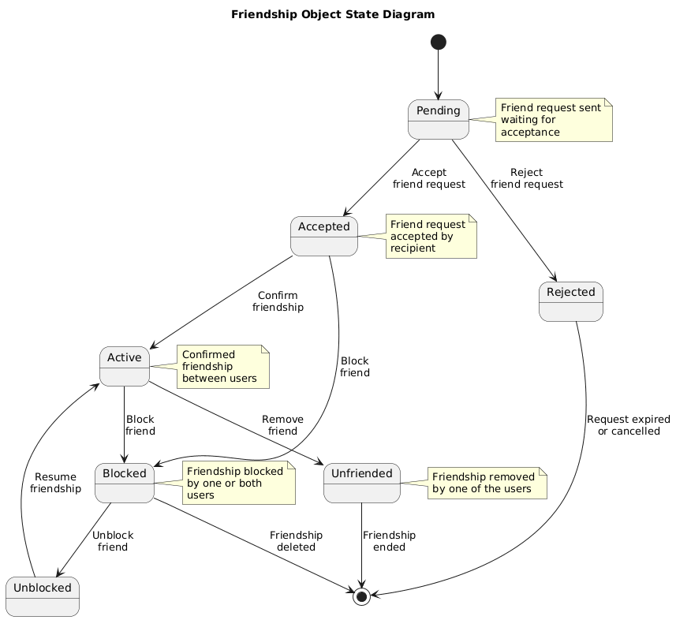

Ownership Report

Item | Owners
Class diagram | Mohamed alaa
State diagram | Mohamed Hussein Goma
Activity diagram | Ahmed Tolba Mohamed
Sequence diagram | Abd El-Rahman Waheed

Policy Regarding Plagiarism:

Students have collective ownership and responsibility of their project. Any violation of academic honesty will have severe consequences and punishment for ALL team members.
- تشجع الكلية على مناقشة الأفكار و تبادل المعلومات و مناقشات الطلاب حيث يعتبر هذا جوهريا لعملية تعليمية سليمة
- ساعد زملاءك على قدر ما تستطيع و حل لهم مشاكلهم فى الكود و لكن تبادل الحلول غير مقبول و يعتبر غشا.
- أى حل يتشابه مع أى حل آخر بدرجة تقطع بأنهما منقولان من نفس المصدر سيعتبر أن صاحبيهما قد قاما بالغش.
- قد توجد على النت برامج مشابهة لما نكتبه هنا أى نسخ من على النت يعتبر غشا يحاسب عليه صاحبه.
- إذا لم تكن متأكدا أن فعلا ما يعد غشا فلتسأل المعيد أو أستاذ المادة.
- فى حالة ثبوت الغش سيأخذ الطالب سالب درجة المسألة ، و فى حالة تكرار الغش سيرسب الطالب فى المقرر.

